Near-Future Changes in Daily Precipitation and Selected Rainfall Extremes over Uttaradit, Thailand Using Bias-Corrected Global Climate Models
Surasit Punyawansiri^{1,*}
¹Office of Water Management and Hydrology, Royal Irrigation Department, Dusit, Bangkok 10300, Thailand
*Corresponding author: Surasit.ku@ku.th
Received … ; Revised … ; Accepted …
Abstract
Bias-corrected climate model output underpins regional impact assessment, yet skill is often reported only for the fitting period, and projected changes are frequently referenced to observations rather than to the model's own corrected baseline. Quantile delta mapping was evaluated under a strict split-sample design and used to quantify near-future precipitation change over Uttaradit Province, northern Thailand. Daily precipitation from seven CMIP6 models under two scenarios was corrected at 13 rain gauges with parameters fitted on 1981–2002 and frozen, evaluated on the independent period 2003–2014, and applied to 2021–2050 against each model's own corrected baseline for 1995–2014. Over the calibration period the mean absolute bias fell from 71.1% to 0.03% for wet-day frequency, from 40.8% to 1.2% for annual total and from 48.2% to 0.02% for the 95th wet-day percentile. Out of sample these became 28.6%, 15.8% and 33.7%, well below the raw models but not negligible; restricting the network to the nine gauges not flagged by a homogeneity screening reduced the mean residual from 26.4% to 13.4%. Indices governed by day ordering were not corrected: the bias in maximum consecutive dry days was 49.8% after correction against 48.4% before it. For 2021–2050 the ensemble median change in annual precipitation is near zero under both scenarios, while heavy-rainfall indices increase under SSP2-4.5 and change little or decrease under SSP5-8.5. Inter-model agreement reaches the 80% threshold for only two of eleven indices, so projections should be interpreted in terms of the components supported by independent validation.

Keywords: Bias correction, CMIP6, Extreme precipitation, Near-future projection, Out-of-sample validation, Quantile delta mapping, Thailand

1. Introduction
Assessments of flood, drought and agricultural risk in monsoon Asia depend on daily precipitation from global climate models (GCMs). Raw GCM precipitation cannot be used directly for local impact modelling: coarse resolution produces excessive low-intensity rainfall and a misrepresented intensity distribution [1,2]. Statistical bias correction is therefore routine, and quantile mapping in its various forms is the most widely applied family of methods [1,3].
Thailand faces substantial exposure to hydroclimatic hazard. Eighty-six severe flood events were reported between 1970 and 2021, affecting more than 61 million people [4]. Observed rainfall extremes over the country have intensified [5,6], and compound hot-rainfall extremes have increased significantly across most of the station network [7]. Projecting how such extremes evolve requires bias-corrected model output whose limitations are understood.
Three weaknesses recur in the applied literature and motivate this study.
First, validation is frequently in-sample. Quantile mapping is a monotone transformation onto the observed empirical distribution, so over the period used to estimate it the corrected series reproduces the observations almost by construction. Calibration-period agreement alone provides limited evidence of out-of-sample transferability. A split-sample design, in which parameters are frozen before they encounter the evaluation period, is the minimum required to support a claim about skill [1,8].
Second, the reference for the projected change is often the observed record. When the future is taken from corrected model output while the baseline is taken from observations, any residual correction error is added directly to the reported climate-change signal. The change must be referenced to the same model's own corrected historical simulation [1].
Third, success on the intensity distribution is generalised to "extremes" as a class. Quantile mapping assigns a new magnitude to each rank; it does not reorder days. Indices defined on runs of days, such as maximum consecutive dry days (CDD) and maximum consecutive wet days (CWD), and on multi-day accumulations such as Rx5day, therefore inherit the model's own temporal structure however well the marginal distribution is matched [9]. This distinction is rarely tested explicitly.
Uttaradit Province in northern Thailand offers a demanding test case: a monsoon-dominated regime with a pronounced dry season, a 13-gauge network spanning a lowland-to-mountain gradient, and a record long enough for a genuine split-sample design yet short enough that station heterogeneity matters.
This study addresses three questions:
RQ1. How effectively does quantile delta mapping reduce biases in daily precipitation during calibration and during independent validation?
RQ2. Which characteristics of precipitation are improved by the correction, and which remain limited because they depend on temporal structure?
RQ3. What near-future changes in precipitation and selected extreme-rainfall indices, for 2021–2050, are supported by the bias-corrected CMIP6 ensemble?
The organising principle is that the reliability of a projection depends on which component of rainfall variability the correction actually corrects.
2. Materials and methods
2.1 Study area and rain-gauge data
Uttaradit Province lies in northern Thailand between 17.16° and 18.37° N and 99.90° and 101.17° E (Figure 1). Elevation ranges from approximately 50 m in the southern lowlands to above 700 m along the north-eastern ridge. The provincial boundary was obtained from the Natural Earth 10 m Admin-1 dataset (ISO 3166-2 code TH-53) [10] and verified for geometry validity, coordinate reference system (EPSG:4326), polygon complexity (378 vertices, confirming that it is not a bounding rectangle) and containment of all 13 gauges; its geodesic area is 7,610.7 km², 2.9% below the commonly cited provincial figure, consistent with cartographic generalisation. Source URL, access date and SHA-256 checksum are recorded in the supplementary material.
Daily rainfall for 1981–2014 was obtained for 13 gauges (Table 1). Mean annual wet-day totals over 1981–2002 range from 954 to 1,326 mm.
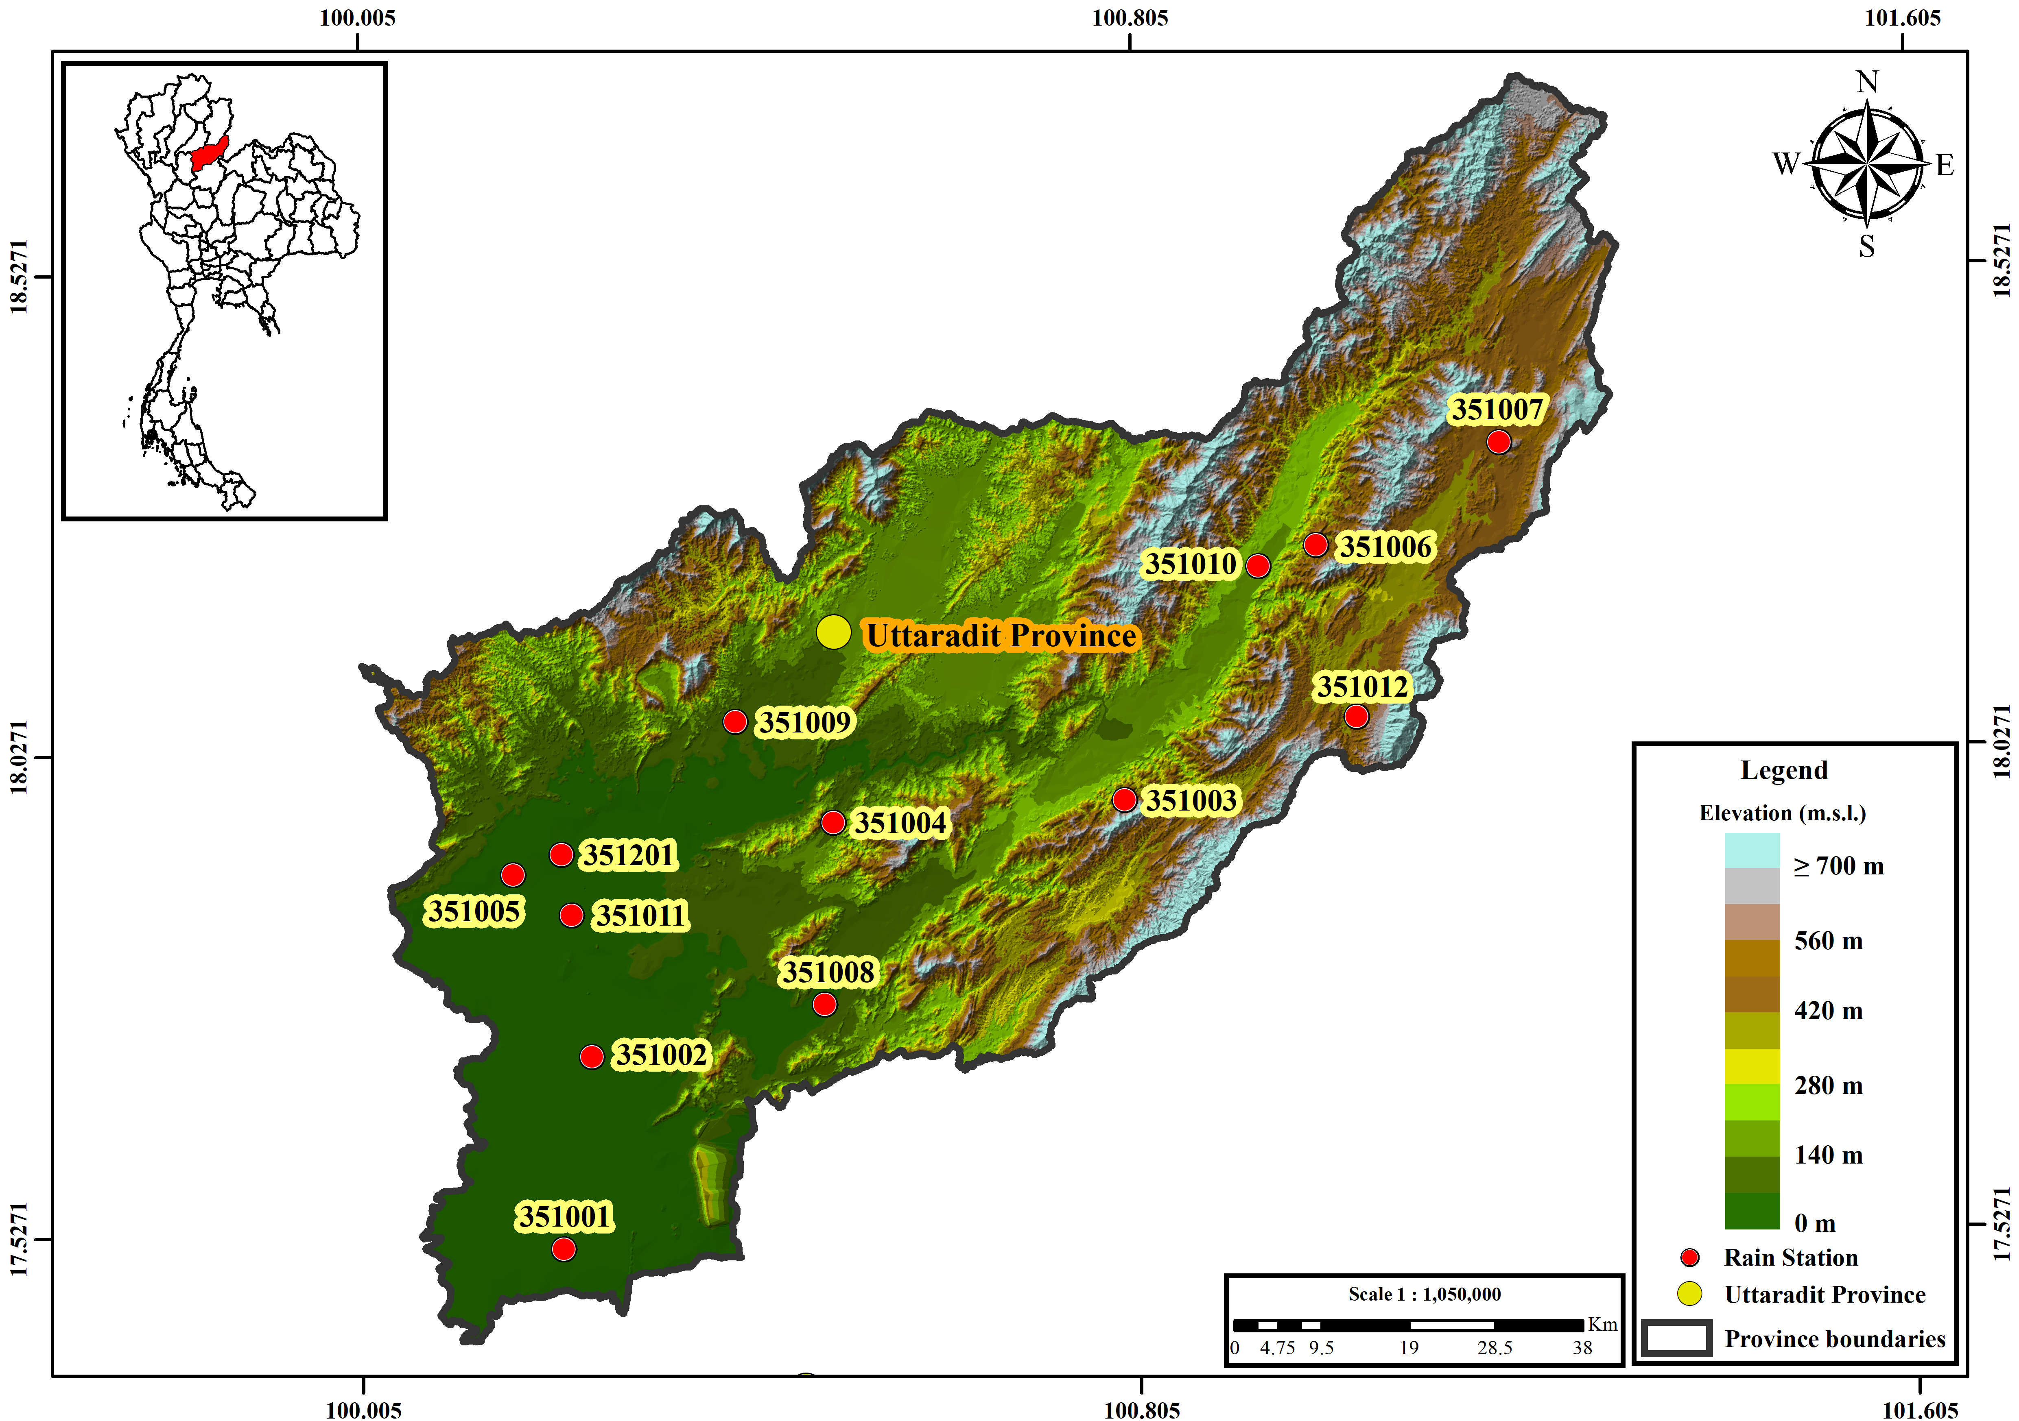
Figure 1 Location of Uttaradit Province in Thailand (inset) and the 13 rain gauges used in this study, over terrain elevation. The provincial boundary is shown in black.
Table 1 Rain gauges used in this study: identifier, coordinates, record period and mean annual wet-day rainfall over 1981–2002. Wet-day frequency, SDII, quality-control flags and the homogeneity screening are given in Supplementary Table S1.
Station | Longitude (°E) | Latitude (°N) | Record | Mean annual rainfall (mm)
351001 | 100.10 | 17.23 | 1981–2014 | 988
351002 | 100.13 | 17.42 | 1981–2014 | 989
351003 | 100.68 | 17.67 | 1981–2014 | 1326
351004 | 100.38 | 17.65 | 1981–2014 | 1154
351005 | 100.05 | 17.60 | 1981–2014 | 1088
351006 | 100.88 | 17.92 | 1981–2014 | 1160
351007 | 101.07 | 18.02 | 1981–2014 | 1168
351008 | 100.37 | 17.47 | 1981–2014 | 1128
351009 | 100.28 | 17.75 | 1981–2014 | 1185
351010 | 100.82 | 17.90 | 1981–2014 | 1148
351011 | 100.11 | 17.56 | 1981–2014 | 1092
351012 | 100.92 | 17.75 | 1981–2014 | 954
351201 | 100.10 | 17.62 | 1981–2014 | 1059
2.2 Quality control of the observed record
Rainfall archives commonly encode missing days as zero, which no completeness check based on null values detects. Every station-month whose total was exactly zero was screened against six diagnostics: the median monthly total at the remaining gauges; the fraction of remaining gauges exceeding 5 mm; the station's own climatological median for that calendar month; the length of the zero run containing the month; and the annual total relative to the station's own median and to the network median. A zero was reclassified as missing only when the surrounding network contradicted it, requiring at least one neighbour-based diagnostic to fire, because within-station diagnostics alone cannot distinguish a genuine regional drought from a data gap, and at least two diagnostics in total.
Of 5,304 station-months, 315 were classified as confirmed dry, all in December–February, 43 as probable missing and 80 as uncertain and left unaltered for sensitivity analysis. The 43 flagged months correspond to 1,308 daily values, 0.810% of the record, which were set to missing; no value was imputed at any stage. Two cases illustrate the screening: August 2008 at gauge 351006 recorded 0.0 mm while all twelve neighbours recorded 11.6–108.7 mm, and October 2004 at gauge 351002 recorded 0.0 mm against neighbour totals of 3.3–333.3 mm.
A homogeneity screening was applied by taking the ratio of wet-day frequency in the validation period to that in the calibration period. Four gauges fall outside the interval 0.75–1.33 and are flagged for potential inhomogeneity: 351003 (2.37), 351005 (1.51), 351006 (0.54) and 351007 (0.58). This ratio is a screening diagnostic, not a formal homogenisation test such as the penalised maximal t test [11]; station history metadata were unavailable, so no formal test could be applied and no gauge is described here as homogeneous or inhomogeneous in the technical sense. The four flagged gauges are retained in the primary analysis and carried as a diagnostic subset.
2.3 CMIP6 data and model configuration
Daily precipitation was used from seven CMIP6 models [13,14] for the historical experiment (1981–2014) and for SSP2-4.5 and SSP5-8.5 (2015–2100): ACCESS-ESM1-5, CESM2, CanESM5, EC-Earth3, FGOALS-g3, MIROC6 and MRI-ESM2-0, all realisation r1i1p1f1 except CESM2 (r11i1p1f1), on the native grid except EC-Earth3 (regular grid). CESM2, CanESM5 and FGOALS-g3 use a 365-day calendar and the remainder the standard calendar; calendars were detected from the data and are compatible between the historical and scenario segments of every model. No model has an overlapping or missing day at the 2014/2015 junction, and implied annual totals of 228–1,342 mm are consistent with millimetres per day. Raw model wet-day frequency ranges from 12.7% to 64.0% against an observed network mean of 36.8%, confirming both the drizzle problem and its opposite in individual models.
Across the 63 gauge columns of the source files the number of distinct daily series per model is only 3 to 15 (CanESM5: 3, with 37 gauges sharing one series). Sub-provincial detail in the raw model fields therefore reflects grid resolution rather than resolved atmospheric structure, and spatial results are presented accordingly (Section 3.5).
2.4 Quantile delta mapping
Quantile delta mapping (QDM) [1] was applied separately for each gauge and each model. Wet days were defined by a 1.0 mm d⁻¹ threshold throughout.
Frequency adaptation was applied before any intensity mapping: the model wet-day threshold was raised until the model wet-day frequency over the calibration period matched the observed frequency [8]. This reduces the wet-day-frequency bias before intensity mapping while retaining the intensity values of days classified as wet.
For a target-period value x with non-exceedance probability p in the target-period model distribution, the corrected value is
BC(x) = F⁻¹_{obs,cal}(p) × [ x / F⁻¹_{mod,cal}(p) ] (1)
where F⁻¹_{obs,cal} and F⁻¹_{mod,cal} are the observed and modelled quantile functions over the calibration period. Empirical distributions were estimated with Hazen plotting positions and linear interpolation. Beyond the calibration range the multiplicative correction ratio at the nearest calibration quantile was held constant; no value was clipped, so a new record extreme remains one. Extrapolation affected 0.41% of wet days on average, with a maximum of 10.6% for a single station-model combination.
2.5 Rainfall indices and performance measure
A set of precipitation and extreme-rainfall indices was calculated following the definitions of the Expert Team on Climate Change Detection and Indices [12] where applicable, supplemented by wet-day frequency and empirical wet-day quantiles: annual wet-day total (PRCPTOT), wet-day frequency, simple daily intensity index (SDII), Rx1day, Rx5day, R10mm, R20mm, R50mm, R95p, R99p, CDD, CWD, and the wet-day quantiles q₅₀, q₉₀, q₉₅ and q₉₉. Percentile thresholds for R95p and R99p were taken from observed wet days over the calibration period at each gauge. All indices were computed identically for observations, raw model output and corrected output, and series were reindexed to a complete daily calendar before any window or spell operation so that no-leap model years are not silently compressed.
Performance is reported throughout as the mean absolute bias, defined for index k as
MAB(k) = (1 / NM) Σ_{i=1}^{N} Σ_{j=1}^{M} | 100 × (S_{ijk} − O_{ik}) / O_{ik} | (2)
where S_{ijk} is the simulated value of index k at gauge i for model j, O_{ik} the observed value, N = 13 gauges and M = 7 models. Signed biases are reported separately in the supplementary material; the two are never interchanged.
2.6 Independent validation
Parameters were estimated on 1981–2002 only and frozen. The frozen parameters were then applied to the calibration period itself, to the independent validation period 2003–2014, to the baseline 1995–2014 and to the future window. The application step never accesses observations of the target period, so the validation is genuinely out of sample.
2.7 Near-future projection and model agreement
Projected change was computed as
Δ(%) = 100 × (BC_{2021–2050} − BC_{1995–2014}) / BC_{1995–2014} (3)
using the same model on both sides. Every statistic for 2021–2050 was recomputed from the daily bias-corrected series over that 30-year window; it is not an average of shorter windows. Inter-model agreement is the fraction of the seven models sharing the majority sign of change; a change is described as robust only when agreement reaches 0.80.
2.8 Interpretation and acceptance criteria
Eight acceptance criteria govern what may be claimed, each carrying a graded status and an explicit limitation rather than a binary pass. Two shape the presentation here. The criterion on temporal dependence is diagnostic only: no numerical threshold is imposed, because quantile mapping is a marginal transformation and any threshold would either fail every method by construction or be met by accident. The criterion on raw-input plausibility screens the scenario-window against the range reported for continental Southeast Asia together with the signal-preservation error of the correction; for 2021–2050 no combination was flagged, and all results reported below are within scope. Gate statuses and the interpretation scope are distributed as machine-readable tables (Supplementary Table S8).
3. Results
3.1 Calibration-period performance
Over 1981–2002 QDM removed almost all of the marginal bias (Table 2, Figure 2). Mean absolute bias across 13 gauges and 7 models fell from 71.1% to 0.03% for wet-day frequency, from 40.8% to 1.2% for PRCPTOT, from 45.3% to 0.01% for SDII and from 48.2% to 0.02% for q₉₅.
The same table shows the limit of that agreement. Rx1day, a pointwise maximum that the correction can rescale directly, improved from 49.1% to 7.3%. The sequence-dependent indices improved far less: Rx5day from 34.5% to 25.5%, CDD from 47.6% to 41.3% and CWD from 90.0% to 35.1%, one to three orders of magnitude worse than the marginal statistics obtained in the same fit.
Table 2 Calibration-period (1981–2002) mean absolute bias, defined by Equation (2), of raw and QDM-corrected CMIP6 daily precipitation against gauge observations, averaged over 13 gauges and 7 models. Marginal-distribution performance only; this table does not imply correction of temporal sequencing or multi-day persistence. Signed biases and the full metric set are given in Supplementary Table S2.
Index | Raw CMIP6 | QDM-corrected
Wet days | 71.14 | 0.03
PRCPTOT | 40.82 | 1.19
SDII | 45.25 | 0.01
q95 | 48.17 | 0.02
Rx1day | 49.11 | 7.27
Rx5day | 34.52 | 25.52
CDD | 47.63 | 41.28
CWD | 89.99 | 35.05
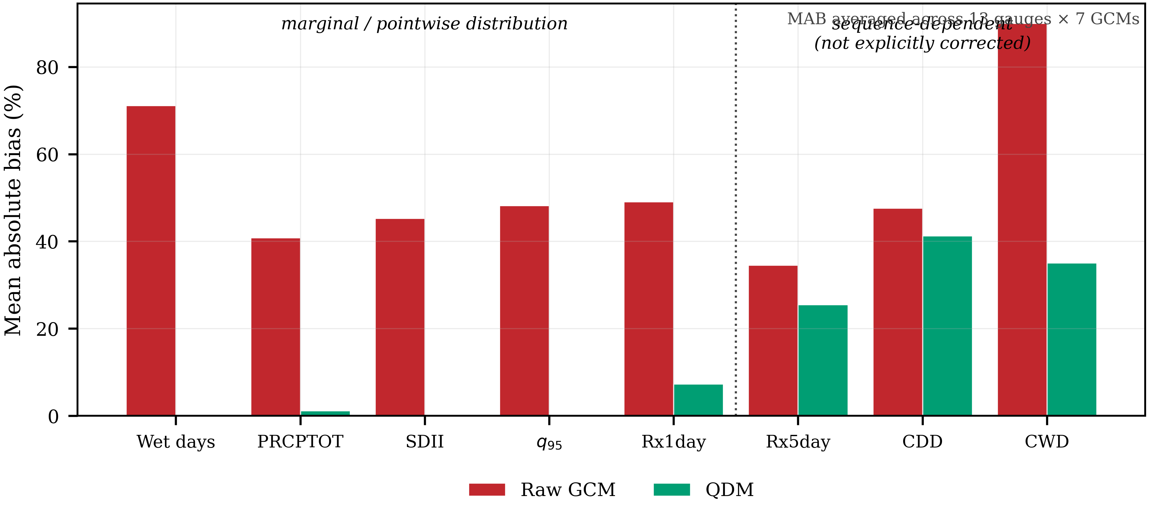
Figure 2 Mean absolute bias of raw and QDM-corrected CMIP6 daily precipitation against gauge observations over the calibration period 1981–2002, averaged across 13 gauges and 7 models. The dotted divider separates statistics primarily controlled by the marginal daily distribution from sequence-dependent and multi-day statistics that are not explicitly reconstructed by quantile mapping.
3.2 Independent validation
Applying the frozen parameters to 2003–2014 gives the transferable performance (Table 3, Figure 3). Mean absolute bias in wet-day frequency is 28.6% against 67.2% for the raw models; PRCPTOT 15.8% against 38.5%; SDII 27.4% against 44.1%; and q₉₅ 33.7% against 48.0%. The correction improves every primary metric, approximately halving the error, but the residual remains substantial.
For sequence-dependent indices the outcome differs. Rx5day improves only from 35.6% to 31.5% and CWD from 83.2% to 38.7%, while CDD is not improved at all: 49.8% after correction against 48.4% before it. The dotted divider in Figure 3 separates the two regimes, and CDD is the single index for which the corrected bar exceeds the raw bar.
Restricting the network to the nine gauges not flagged by the homogeneity screening reduced the mean residual across the four primary metrics from 26.4% to 13.4% (Supplementary Table S4). This is an association between station heterogeneity and validation error and does not establish that those gauges account for a specific share of it; the full network remains the primary result.
Table 3 Independent validation (2003–2014) of QDM-corrected CMIP6 precipitation against observations, using parameters fitted on 1981–2002 and frozen. Mean absolute bias as defined by Equation (2), averaged over 13 gauges and 7 models. Signed biases are given in Supplementary Table S3 and the homogeneity sensitivity in Supplementary Table S4.
Index | Raw CMIP6 | QDM-corrected
Wet days | 67.22 | 28.62
PRCPTOT | 38.45 | 15.82
SDII | 44.08 | 27.37
q95 | 47.95 | 33.69
Rx1day | 47.38 | 26.85
Rx5day | 35.63 | 31.52
CDD | 48.43 | 49.84
CWD | 83.19 | 38.73
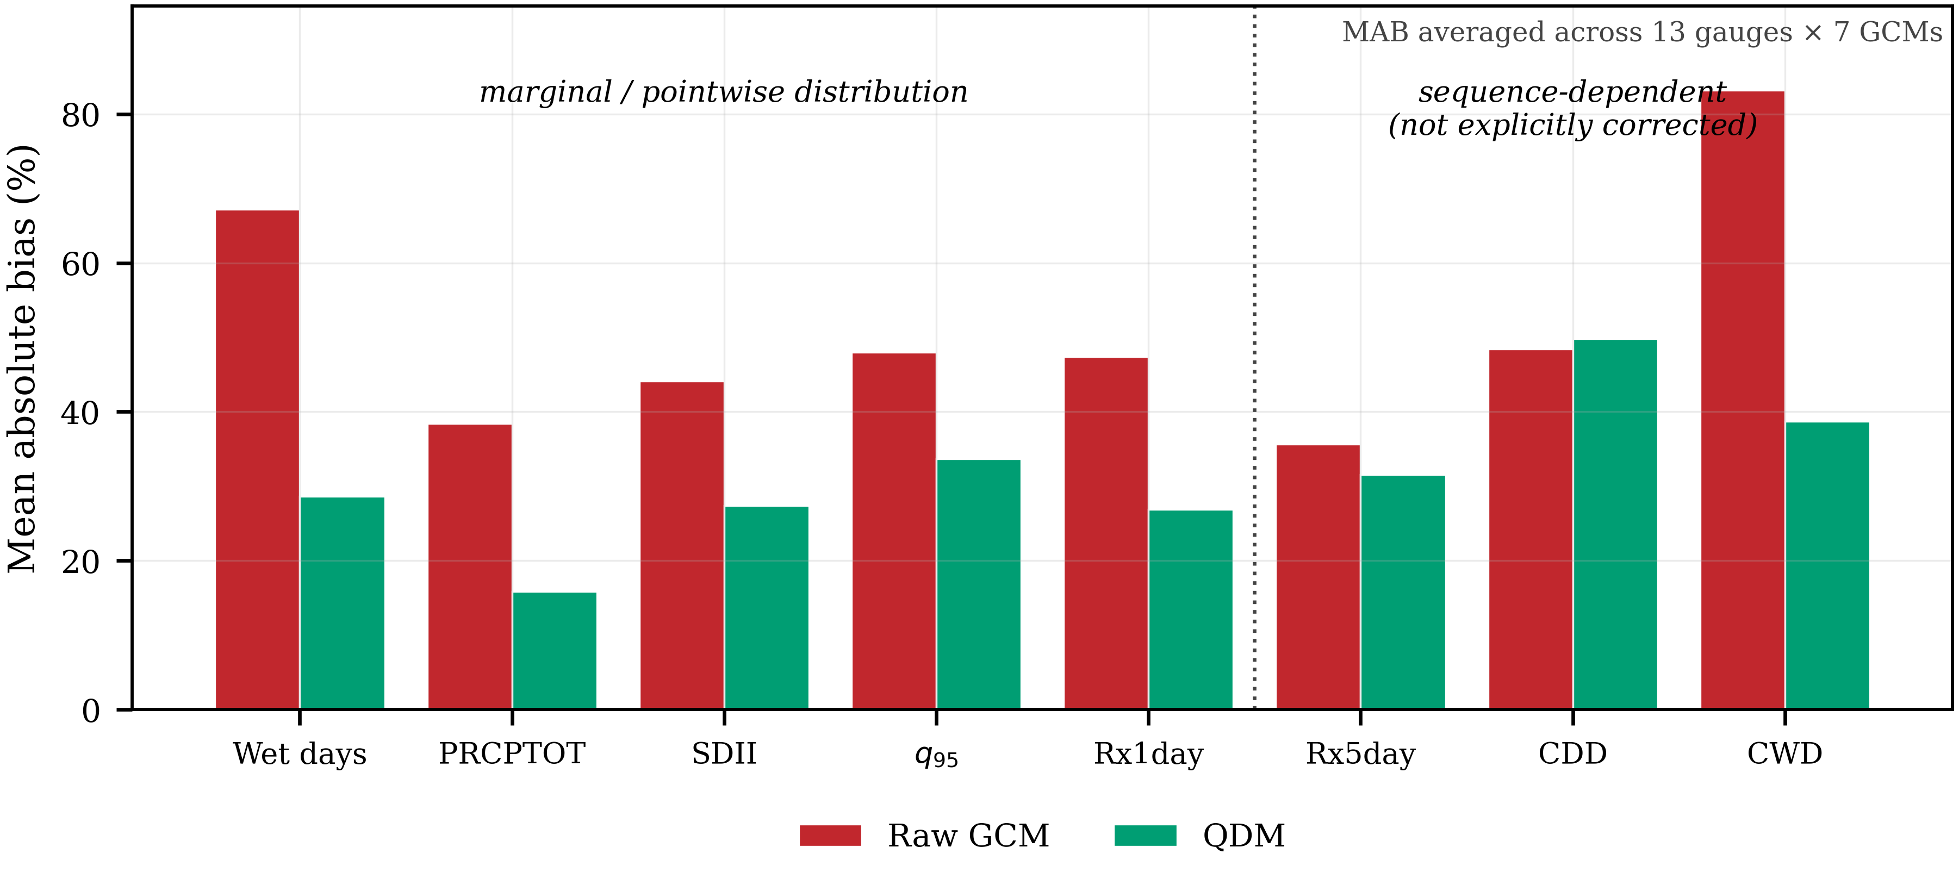
Figure 3 As Figure 2, for the independent validation period 2003–2014 using parameters fitted on 1981–2002 and frozen. Axes are identical to Figure 2 to allow direct comparison. CDD is the only index for which the corrected bias exceeds the raw bias.
3.3 Near-future precipitation changes, 2021–2050
Projected changes in the bulk precipitation characteristics are small (Table 4, Figure 4). The ensemble median change in annual wet-day total is +0.1% under SSP2-4.5 and +0.7% under SSP5-8.5, with inter-model interquartile ranges of −1.5% to +8.2% and −7.0% to +6.2% respectively, straddling zero in both cases. Wet-day frequency changes by +0.5% and +2.4%.
SDII behaves differently between scenarios: +2.1% under SSP2-4.5, where it is one of only two indices in the whole analysis to reach the 0.80 agreement threshold, and −1.3% under SSP5-8.5. Agreement is 0.57 for the bulk characteristics under both scenarios, corresponding to four of seven models sharing the majority sign, barely above the value expected by chance.
Table 4 Projected change for 2021–2050 relative to each model's own bias-corrected baseline (1995–2014), from Equation (3). For each scenario the ensemble median, the inter-model interquartile range in square brackets and the agreement fraction in parentheses are given; bold denotes agreement of at least 0.80. Indices marked "diagnostic" depend on the ordering of wet and dry days, which quantile mapping does not correct (Section 3.2).
Index | Type | SSP2-4.5 | SSP5-8.5
PRCPTOT | projection | 0.1 [-1.5, 8.2] (0.57) | 0.7 [-7.0, 6.2] (0.57)
Wet-day frequency | projection | 0.5 [-2.2, 2.9] (0.57) | 2.4 [-3.9, 3.2] (0.57)
SDII | projection | 2.1 [0.5, 5.8] (0.86) | -1.3 [-2.3, 4.5] (0.57)
Rx1day | projection | 8.3 [-2.8, 12.4] (0.71) | -3.8 [-11.1, 4.8] (0.71)
Rx5day | diagnostic | 7.6 [-0.1, 14.7] (0.71) | -1.9 [-6.6, 14.5] (0.57)
R20mm | projection | 6.7 [-2.5, 16.2] (0.71) | -7.5 [-10.4, 10.2] (0.57)
R50mm | projection | 27.0 [6.7, 38.5] (0.71) | 0.8 [-22.4, 18.0] (0.57)
R95p | projection | 14.9 [0.2, 20.8] (0.71) | -4.9 [-21.9, 12.4] (0.57)
R99p | projection | 29.5 [-7.3, 45.3] (0.71) | 16.3 [-31.5, 45.9] (0.57)
CDD | diagnostic | -2.1 [-4.4, 7.2] (0.57) | 0.4 [-3.4, 10.9] (0.57)
CWD | diagnostic | 6.6 [2.1, 11.5] (0.86) | 4.5 [3.1, 12.4] (0.86)
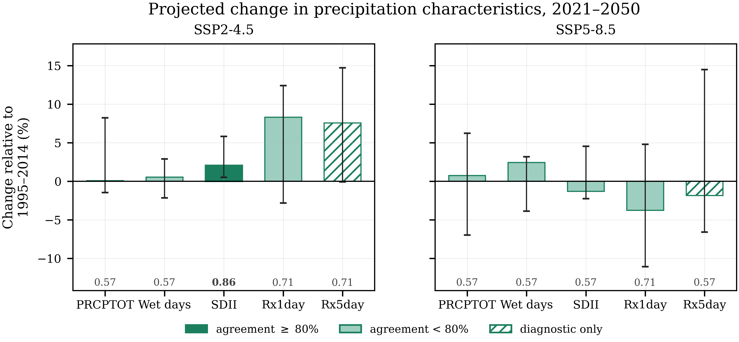
Figure 4 Projected change in precipitation characteristics for 2021–2050 relative to each model's own bias-corrected baseline (1995–2014). Bars are ensemble medians and whiskers denote the inter-model interquartile range, which represents inter-model spread and not a confidence interval. The number beneath each bar is the inter-model agreement fraction; bold marks agreement of at least 0.80, and those bars are filled solid.
3.4 Near-future rainfall extremes
The extreme-rainfall indices show a clearer scenario contrast than the bulk characteristics (Table 4, Figure 5).
Under SSP2-4.5 every intensity and tail index increases: Rx1day +8.3%, R20mm +6.7%, R50mm +27.0%, R95p +14.9% and R99p +29.5%, all at 0.71 agreement. The interquartile ranges are wide, spanning +6.7% to +38.5% for R50mm and −7.3% to +45.3% for R99p, so the direction is more consistent than the magnitude.
Under SSP5-8.5 the same indices change little or decrease: Rx1day −3.8%, R20mm −7.5%, R50mm +0.8%, R95p −4.9% and R99p +16.3%, all at 0.57 agreement. The absence of scenario ordering, with the lower-forcing scenario producing the larger increase in heavy rainfall, is discussed in Section 4.3.
CDD changes by −2.1% and +0.4% and CWD by +6.6% and +4.5%; CWD reaches 0.86 agreement under both scenarios. Following Section 3.2 these two indices, together with Rx5day, are reported as diagnostics rather than as corrected projections and are drawn as open hatched bars in Figure 5.
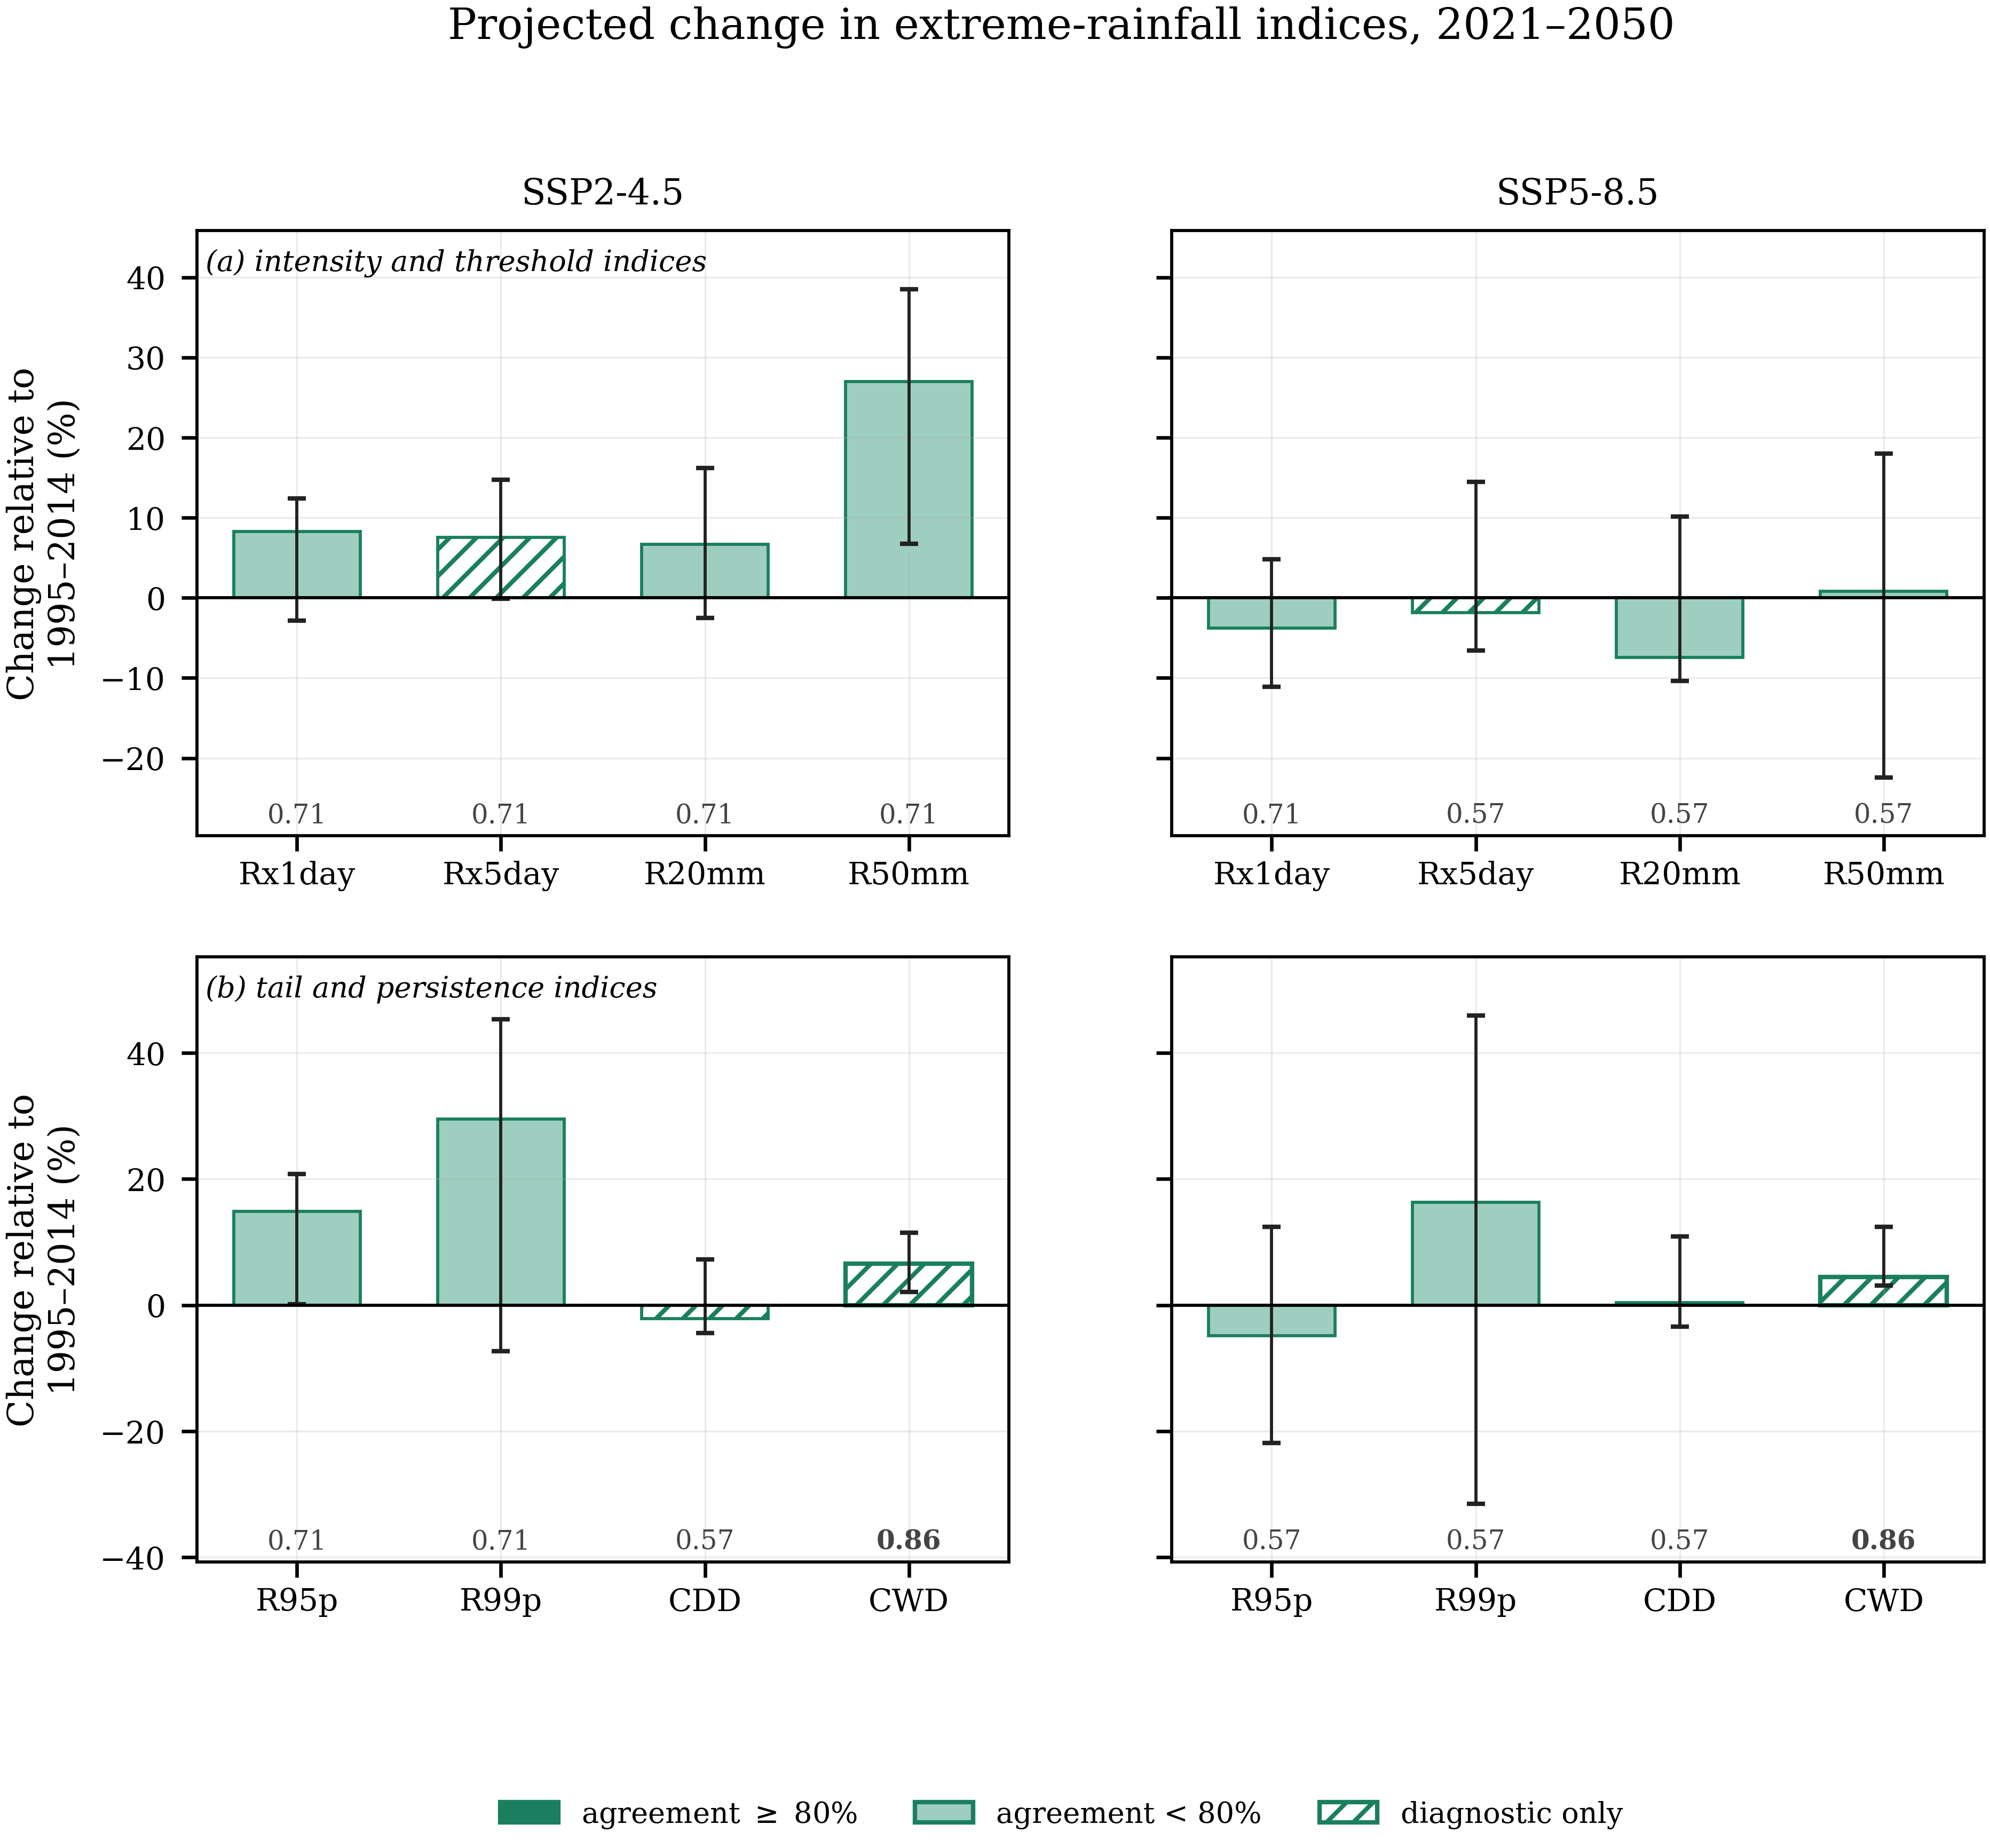
Figure 5 As Figure 4, for the extreme-rainfall indices: (a) intensity and threshold indices and (b) tail and persistence indices. CDD, CWD and Rx5day depend on the ordering of wet and dry days, which quantile mapping does not correct; they are drawn as open hatched bars and are reported as diagnostics rather than as corrected projections.
3.5 Gauge-level spatial pattern and model agreement
Figure 6 shows the ensemble median change in annual precipitation at each gauge, with an inverse-distance-weighted interpolation between the gauges as background. Under SSP2-4.5 the increases are concentrated in the southwestern lowlands and along the central axis, with small decreases in the northeast; under SSP5-8.5 the pattern is weaker and of mixed sign. Only two of 26 gauge-scenario combinations reach the 0.80 agreement threshold.
The interpolated surface is a spatial visualisation of gauge-level ensemble median changes rather than a spatially resolved climate-model field. Because the raw model output resolves only 3 to 15 distinct series across the province (Section 2.3), the smooth gradients in Figure 6 arise from the interpolation between corrected gauge series and must not be read as structure resolved by the models. The gauges are drawn on top of the surface so that the distinction between the analysed points and the interpolation between them remains visible.
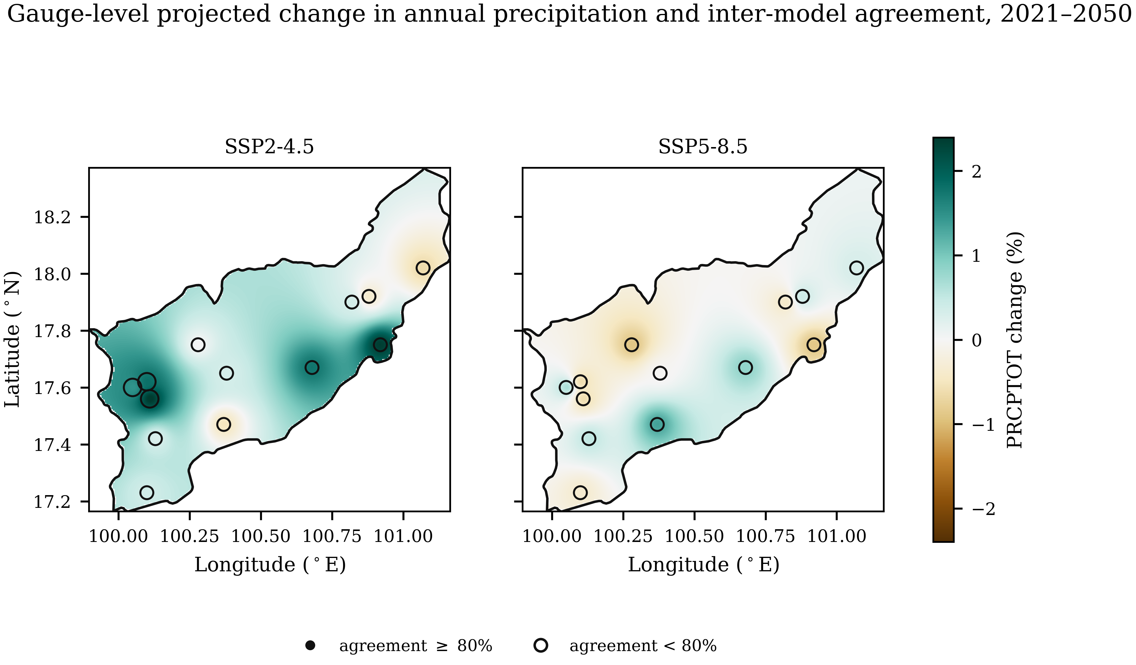
Figure 6 Ensemble median change in annual precipitation for 2021–2050 relative to each model's own bias-corrected baseline. The shaded surface is an inverse-distance-weighted interpolation between the 13 gauges, clipped to the verified provincial boundary; the gauges themselves are drawn on top, sized by the inter-model agreement fraction, with filled symbols for agreement of at least 0.80 and open symbols below it.
4. Discussion
4.1 Calibration is not validation
The contrast between Tables 2 and 3 is the clearest outcome of this study. Over the calibration period QDM reproduces the observed intensity distribution to within 0.03%; over an independent twelve years the same frozen parameters leave 15.8–33.7% residual error. The first figure is a property of the estimator, because a monotone map onto an observed empirical distribution must reproduce that distribution, and carries little information about transferability.
The residual is not evenly distributed. Four of thirteen gauges change their own wet-day frequency by more than a third between the two periods, and no correction calibrated on the first period can reproduce the second at those gauges. This pattern may reflect nonstationarity or inhomogeneity in the observational records, changes in the model–observation relationship, sampling variability, or an interaction of these; station metadata were unavailable to distinguish among them. Comparable screening has led other Thai studies to remove affected stations after formal testing [7,11]; that option was not available here, so the four flagged gauges are retained with disclosure and treated as a diagnostic subset.
4.2 Marginal correction versus temporal dependence
Quantile mapping assigns a new magnitude to each rank; beyond the wet–dry reclassification implied by frequency adaptation, it does not change which days are wet relative to one another, so indices defined on the sequence retain the model's own persistence structure. The evidence here is direct: after a correction that reproduces the wet-day intensity distribution to within 0.03%, CDD remains biased by 41.3% in sample and 49.8% out of sample, the latter marginally worse than the uncorrected model. Frequency adaptation improves part of the sequencing, with the transition probability P(wet | wet) improving from a bias of 6.9% to 0.6% because raising the wet-day threshold changes which days count as wet, but the lag-1 autocorrelation of occurrence is not improved (−6.5% raw against −7.1% corrected) and spell-length statistics retain biases of 10–12%.
The consequence for impact studies is specific. Projections of accumulated volumes and of intensity-based design quantities rest on the component of the correction that demonstrably works; projections of drought duration, spell length and multi-day accumulation rest on the component that does not, and require either a method that models occurrence explicitly, such as a stochastic weather generator, or explicit acknowledgement of the limitation. This is why CDD, CWD and Rx5day are labelled diagnostic throughout and are not offered as corrected projections.
4.3 What the 2021–2050 projections support
Two features of Table 4 deserve comment.
The first is the contrast between the bulk characteristics and the extremes. Annual precipitation is essentially unchanged under both scenarios, yet the heavy-rainfall indices under SSP2-4.5 increase by 7–30%. Rainfall totals redistributing towards heavier events without a change in the annual sum is a physically coherent expectation under warming, and is consistent with the observed intensification of daily rainfall intensity reported for Thailand [5,6]. The result should nevertheless be treated cautiously, because the agreement fraction for those indices is 0.71, that is five of seven models.
The second is the absence of scenario ordering: the lower-forcing scenario produces the larger increase in heavy rainfall over this window. Over a near-future horizon the forced difference between SSP2-4.5 and SSP5-8.5 is small, and each model here contributes a single realisation, so a large initial-condition ensemble would be required to separate the forced response from internal variability. The non-monotonic scenario response and the limited inter-model agreement together indicate that the forced precipitation signal is difficult to distinguish from internal variability and inter-model spread at the scale of this study.
The practical reading is therefore restricted. Only SDII under SSP2-4.5 and CWD under both scenarios reach the 0.80 agreement threshold, and CWD is a diagnostic quantity. Every other entry in Table 4 should be cited as an ensemble estimate with low to moderate inter-model agreement, not as a robust regional signal. This does not contradict the observed intensification of rainfall and compound extremes reported for Thailand as a whole [5–7]: national-scale detection over five decades and provincial-scale projection from a seven-member ensemble are different problems with different signal-to-noise characteristics.
4.4 Limitations
The provincial boundary rests on a single verified source; every other dataset reachable during this work returned an identical geometry, so the cross-check is not independent, and the Natural Earth polygon is a generalised cartographic product. Station history metadata were unavailable, so the four screened gauges remain flagged rather than formally tested. Each model contributes one realisation. The observed record is 34 years, short for precipitation trend detection. Raw model fields resolve 3 to 15 distinct series across the province, limiting spatial inference. Only two emission scenarios were available, so scenario uncertainty is not fully sampled. The analysis is confined to a single near-future window; mid- and late-century horizons were not assessed.
5. Conclusion
Quantile delta mapping reduced the mean absolute bias in wet-day frequency, annual total and wet-day intensity of seven CMIP6 models from 40–71% to below 1.2% over the calibration period, and to 15.8–33.7% over an independent period. In-sample agreement is a property of the method and is not evidence of transferable skill.
The correction does not extend to indices governed by the ordering of wet and dry days: out of sample, the bias in maximum consecutive dry days was 49.8% after correction against 48.4% before it. Marginal bias correction and temporal dependence are separate problems, and results for CDD, CWD and Rx5day should not be described as corrected.
Restricting the network to the nine gauges not flagged by the homogeneity screening reduced the network-mean validation error from 26.4% to 13.4%, indicating that observational heterogeneity may constrain achievable out-of-sample performance.
For 2021–2050 the ensemble median change in annual precipitation is close to zero under both scenarios, while heavy-rainfall indices increase by 7–30% under SSP2-4.5 and change little or decrease under SSP5-8.5. Inter-model spread is substantial for every index.
Only signals with adequate model agreement should be interpreted as more robust. In this analysis that condition is met by SDII under SSP2-4.5 and by CWD, a diagnostic quantity, under both scenarios. The reliability of a bias-corrected projection depends on which component of rainfall variability the correction actually corrects; reporting that component explicitly, and declining to interpret what falls outside it, is the practical recommendation of this work.
6. Ethical Approval
Not applicable. This study used meteorological station records and publicly archived climate model output, and involved no human participants or animals.
7. Declaration of Generative AI and AI-Assisted Technologies in the Writing Process
During the preparation of this work the author used a generative AI assistant to support code review, statistical verification and language editing. After using this tool, the author reviewed and edited the content as needed and takes full responsibility for the content of the publication.
8. Acknowledgements
The author thanks the Royal Irrigation Department and the Thai Meteorological Department for access to the rain-gauge records, the World Climate Research Programme for coordinating CMIP6, and the modelling groups listed in Section 2.3 for producing and making available their model output.
9. Author Contributions
Punyawansiri, S.: Conceptualization, Methodology, Software, Formal analysis, Data curation, Validation, Visualization, Writing – original draft, Writing – review & editing.
10. Conflicts of Interest
The author declares no conflict of interest.
11. References
[1] Cannon AJ, Sobie SR, Murdock TQ. Bias correction of GCM precipitation by quantile mapping: how well do methods preserve changes in quantiles and extremes? J Clim. 2015;28(17):6938-6959.
[2] Maraun D. Bias correcting climate change simulations: a critical review. Curr Clim Change Rep. 2016;2(4):211-220.
[3] Teutschbein C, Seibert J. Bias correction of regional climate model simulations for hydrological climate-change impact studies: review and evaluation of different methods. J Hydrol. 2012;456-457:12-29.
[4] United Nations Economic and Social Commission for Asia and the Pacific. Risk and Resilience Portal: Thailand country report [Internet]. 2025 [cited 2026 Aug 30].
[5] Limsakul A, Singhruck P. Long-term trends and variability of total and extreme precipitation in Thailand. Atmos Res. 2016;169:301-317.
[6] Limsakul A. Changes of daily rainfall intensity in Thailand from 1955 to 2019. Asia Pac J Sci Technol. 2022;27(1):1-3.
[7] Paengkaew W, Limsakul A, Aroonchan N, Santisirisomboon J, Srisawadwong R, Amnuaylojaroen T, et al. Increasing compound hot-rainfall extreme in Thailand during 1970-2022. Asia Pac J Sci Technol. 2026;31(1):APST-31-01-02.
[8] Themeßl MJ, Gobiet A, Heinrich G. Empirical-statistical downscaling and error correction of regional climate models and its impact on the climate change signal. Clim Change. 2012;112(2):449-468.
[9] Addor N, Rohrer M, Furrer R, Seibert J. Propagation of biases in climate models from the synoptic to the regional scale: implications for bias adjustment. J Geophys Res Atmos. 2016;121(5):2075-2089.
[10] Natural Earth. Admin 1 – states, provinces, 1:10m cultural vectors [Internet]. [cited 2026 Aug 30]. Available from: https://www.naturalearthdata.com
[11] Wang XL. Accounting for autocorrelation in detecting mean shifts in climate data series using the penalized maximal t or F test. J Appl Meteorol Climatol. 2008;47(9):2423-2444.
[12] World Climate Research Programme. Climate change indices. In: Expert Team on Climate Change Detection and Indices (ETCCDI) [Internet]. 2020 [cited 2026 Aug 30].
[13] Eyring V, Bony S, Meehl GA, Senior CA, Stevens B, Stouffer RJ, et al. Overview of the Coupled Model Intercomparison Project Phase 6 (CMIP6) experimental design and organization. Geosci Model Dev. 2016;9(5):1937-1958.
[14] O'Neill BC, Tebaldi C, van Vuuren DP, Eyring V, Friedlingstein P, Hurtt G, et al. The Scenario Model Intercomparison Project (ScenarioMIP) for CMIP6. Geosci Model Dev. 2016;9(9):3461-3482.
Note to the author: references [1–14] are those cited in the present draft. Model-description papers for the seven CMIP6 models used must be added and cited in Section 2.3, and the reference list renumbered accordingly. The bibliographic details of [4], [6], [7], [10] and [12] should be confirmed against the sources before submission.

